# C:\Users\James\AppData\Local\Microsoft\Windows\INetCache\Content.Word\1510864_10152222978819882_1653651865_n.jpg

Integration Guidelines

#### Jonathan Caine

# Document Control

|  |  |  |  |  |
| --- | --- | --- | --- | --- |
| Version Number | Modified By | Date | Section(s) Modified | Comments |
| *1.0* | *J. Caine* | *16/04/2014* | *11* | *Document created* |
|  |  |  |  |  |
|  |  |  |  |  |
|  |  |  |  |  |
|  |  |  |  |  |
|  |  |  |  |  |
|  |  |  |  |  |
|  |  |  |  |  |
|  |  |  |  |  |
|  |  |  |  |  |
|  |  |  |  |  |
|  |  |  |  |  |

Contents

[1 Introduction 1](#_Toc384467469)

[1.1 Heading 2 1](#_Toc384467470)

[1.1.1 Heading 3 1](#_Toc384467471)

# Introduction

The purpose of this document is to guide employees through the process of integrating user stories into the eCook product. Step-by-step instructions will be provided along with screen shots where necessary; however this document should not be regarded as a complete guide, as different user stories will require slightly different levels of work to be integrated, so parts will be left to the reader’s discretion.

Should any problems arise during the integration process, or queries relating to this document or the process, then please contact the Development Manager, Jonathan Caine. In his absence the Software Manager, Stephen Thorpe should be the point of contact.

# Integration Process

## 2.1 Preparation

Before starting please ensure that that your user story is considered complete, any JUnit tests have been written, and pass when run, the eclipse project for the user story has been uploaded to GitHub, and the appropriate user story/tasks/bugs are in the “Ready to Integrate” column on Jira.

## 2.2 Transferring Source Code into eCook Project

Open up the GitHub desktop application, and run a sync for the SWENG repository. Open up eclipse and import the eCook project directly from the repository, without copying the files into your eclipse workspace. Now import the project for the user story that you wish to integrate into eCook, using the same method as above.

Your user story project should contain at least 1 “.java” source file, and 1 “.java” test file for each source file. These should be under an appropriately named package (“default” is NOT acceptable and won’t work in eCook!).

Right click on the package name in the user story project and select “copy”. Under the eCook project, right click on the folder called “src” and select “paste”. This should paste the entire contents of the package from your user story project, into a package with the same name under eCook.

If for any reason this fails to work then repeat the copy-paste part of the process.

## 2.3 Copy-Paste Verification

To verify that all source and test code was copied correctly, expand the new package in eCook, open up any test files, and execute the JUnit tests. All JUnit tests should still pass, as no changes have been made to eCooks source code at this stage.

If this is not the case, then try looking at the JUnit stack trace to see if you can identify the problem/s. If you still encounter problems then please contact either the QA Manager or Development Manager for further guidance.

## 2.4 Adapting eCook

Now the new user story needs to be called from within eCook. This requires adding the appropriate code, into the relevant existing source files in eCook. This process will be different for each user story, so is difficult to describe.

You need to find all of the places in the existing code base that the new class/classes need to be called from. This is not as simple as it might first seem. For example if the Main Menu code is being integrated, this code should either go into the main eCook package, or into its own one depending on what methods it requires access to from the current eCook project. This is similar to name-spacing in the C programing language, and effects the scope of all the variables and methods contained with the class/classes. If you are unsure on what this means please speak to the Development Manager or Software Manager.

You would need to add code to display the Main Menu when the product is first launched (this does not properly exist currently, we start with a blank scene with a button labelled “Create SlideShow”), also edit parts of the code in the SlideShow class so that if the slide show tries to go beyond the last, or before the first slide, the slide show ends and the Main Menu is again displayed. Code would also need adding to handle when the “Exit Slide Show” button is pressed, again to return to the Main Menu, and similarly if the “ESC” key was pressed during a slide show. The Main Menu class would need editing to be able to call the XML Parser, File Browser, Http Recipe Access, and new SlideShow classes. Etc etc …

You are finished adapting the eCook code only when you can successfully run the eCook project without any errors (don’t forget to check the stack trace after you have run it for uncaught exceptions!), and all existing functionality of eCook can be handled by the new user story, and the new functionality for the user story can be handled by eCook. This is where the readers discretion comes in, and if further specific guidance is required, then please contact the Development Manager to find a convenient time when he can pair programme with you to assist.

## 2.5 Verification of Integration

Now any JUnit tests in eCook should be run. There will be several test classes, theoretically 1 for every source class. Each of these should be executed and the results green, otherwise somewhere along the line the existing functionality of eCook has been effected by the integration.

If problems are encountered at this stage, please look at which tests are failing and why before contacting a member of the Software Team. Often it is something really simple like a miss-declaration or typo, where the calling code for the new user story in eCook has been added. If you can’t find the cause, please then contact a member of the Software Team for further advice.

**NOTE** – some test classes are incomplete or contain errors currently, do not worry about executing these classes, as obviously they will fail before the integration anyway. You only need to be concern about test classes that would have passed before the integration took place.

# 3. Deterministic Test Pass (DTP)

## 3.1 Conducting a DTP

On Jira move the relevant user story/tasks/bugs into the “Integration Testing (DTP)” column.

Navigate to and open the blank DTP record card located at;

[\\SWENG\Documents\Software\Testing and Integration\eCook's DTP Record.xlsx](Testing%20and%20Integration/eCook's%20DTP%20Record.xlsx)

Step through and execute each of the tests in order. Enter a “PASS” or “FAIL” into the results column; if an individual step fails please enter a comment as to why in the comments column. Should any test step or test as a whole fail at this stage, this should be considered a priority problem as it means that the existing functionality of eCook has been regressed (broken). Please contact the Development Manager or Software Manager as soon as feasibly possible for further advice.

**NOTE** – some scenarios have been agreed as acceptable failures in order to aid progression through the iterations. The Development Manager or Software Manager can advise on this.

## 3.2 Uploading DTP Results

Once your DTP is complete and all tests passed, a copy of the DTP record should be saved to the above location, named as “eCooks DTP Record – *user story name*.xlsx”. This should then also be uploaded to each user story/task/bug that was covered by the integration (Don’t forget sub-stories as well!!), on Jira. To do this, open the Kanban board view, click on the issue you want to upload the file to, in the issue view window that opens on the right hand side scroll down to and click on where it says “Attach Files”.

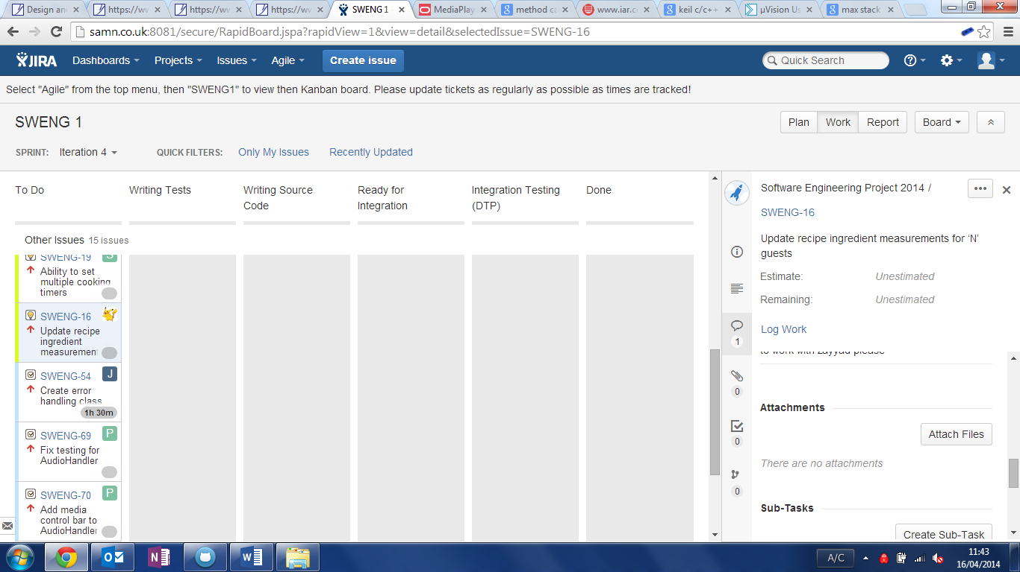

Click on the “Choose Files” button, and navigate to the location you saved the file to (see above). In the comments box put something along the lines of “Integration testing for *user story name* into eCook”, and click attach.

Now log the appropriate amount of time taken to complete the integration on Jira. Do this on the top level user story, which should appear as a single line above any sub-stories you have created.

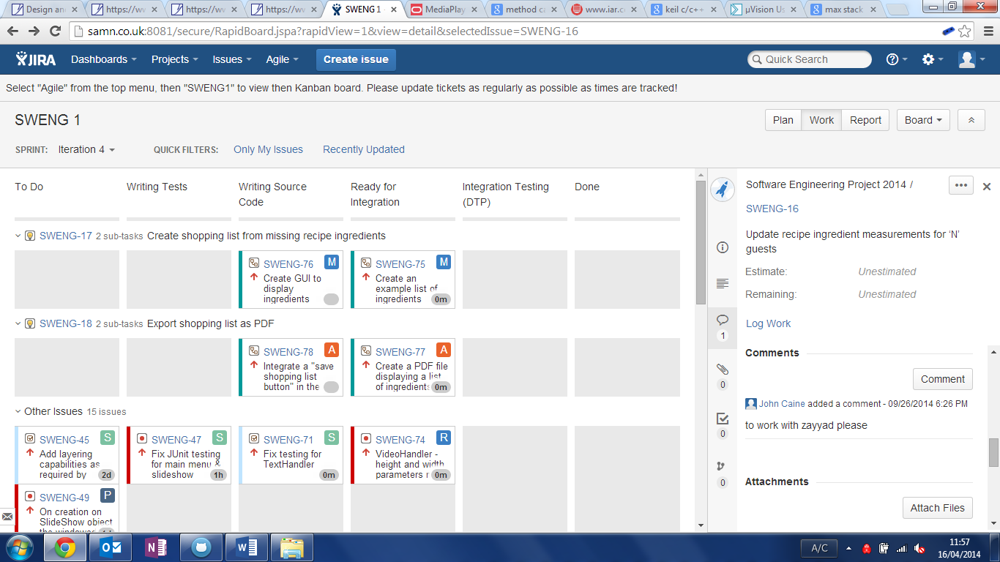

# 4. Final Steps

## 4.1 Marking as “Done” on Jira

Now drag any sub-user stories/tasks/bugs you have integrated into the “Done” column on Jira. As you drag the last sub-user story into the “Done” column a window will pop up asking you if you wish to move the top level user story also into the “Done” state. Please click the “Confirm” button to do this. If for some reason you miss this window, after all sub-user stories are in the “Done” column, a button will appear on the same line as the top level user story but at the far right hand side. It will say something like “Mark as Done”, click this and it will have the same effect.

## 4.2 Committing to GitHub

All that is left to do is to commit your changes to GitHub. Reopen the GitHub desktop application if you have closed it, and open the SWENG repository. The changes you have made will load, please add as detailed a comment as possible to the commit message (these are becoming absolutely vital as we all start working directly on eCook, and Git merges are required as a result!). Commit your changes to Master, and run a sync to they are pushed upstream to GitHub.

## 4.3 Notifying the Software Team

Finally contact the Software Team to notify them you have finished your user story/tasks/bugs. They will review the code and integration, and raise any issues found as soon as possible. They may also assign you additional work if you have completed your work early.